AutoSAP RBP & RWP Hourly Monitoring
Solution Manager signatures signify that approvers have read, understood, and agrees with the content of this document.
Name | Job Title and Role
Akoju Sharanya | The author is signing to confirm that this document has been prepared in accordance with an approved document management process, that content is consistent with the deliverable definition found in Specify System, that relevant input from any contributory authors has been included and that an appropriate review / editing process has been conducted.
Akoju Sharanya | The Developer (selected by the Project Manager as responsible for the design of the system) is signing to confirm that the Design Specification is fit for purpose, that it will deliver a computer system that satisfies the System Requirements and that it will be used for the development or configuration of the computer system

Table of Contents
1 Introduction 3
2 Definition/Acronyms 3
3 General Statement of Design 3
3.1 Assumptions 3
4 References 3
5 Platform Architecture and Environment 3
6 Software Architecture 4
6.1 Generic Solution Details 5
7 System Operation Specification 8
8 Data 8
9 Security 8
10 Revision History 8
11 Appendices 8
11 Appendix-Program Logic 9

Introduction
The system will log in to the RBP and RWP systems to monitor different T-Codes such as rz03, sm58, smlg, smq1, smq2, st04(Hana replication) sm14, and ldap. It will send a monitoring report every hour. This document describes the automation process of hourly RBP and RWP system monitoring.

Definition/Acronyms
Item | Definition
API | Application Programme Interface
SAP | Systems Applications and Products

General Statement of Design
Design methodology/principles | This task is developed to overcome the manual effort and time spent on routine activity. The scripts are developed for end-end execution of Automation process of RBP and RWP hourly Monitoring.  Automation script will login to RBP and RWP systems of SAP to check all the t-codes such as rz03, sm58, smlg, smq1, smq2, st04, sm14, and ldap and sends monitoring mail for every 1hr along with the evidence.
Tools + version | Python 3.6, Pandas, SAP GUI 760, wincom32 API, SMPT mail
Programming standards | GSK Programming Standards.

Assumptions
Assuming the t-codes such as rz03, sm58, smlg, smq1, smq2, st04, sm14, and ldap are working fine.

References
None

Platform Architecture and Environment
Python 3.6

Software Architecture
Element ID | Developed Software Unit name | ID | Programming Language(s) | Description of Purpose
DS/Basis_RBP&RWP-hourlymonitoring/0001 | Program | autosaprbp.py | Python | This is the main file which imports all the other files and executes the operation.
DS/Basis_RBP&RWP -hourlymonitoring/0002 | Program | cc.py | Python | This file reads the credentials to login to the system
DS/Basis_RBP&RWP -hourlymonitoring/0003 | Program | logon.py | Python | This file will login into SAP GUI
DS/Basis_RBP&RWP -hourlymonitoring/0004 | Program | ldap.py | Python | Checks status for only RBP system
DS/Basis_RBP&RWP -hourlymonitoring/0005 | Program | rz03.py | Python | Checks all servers active or not.
DS/Basis_RBP&RWP -hourlymonitoring/0006 | Program | sm14.py | Python | Checks status of system Active or not.
DS/Basis_RBP&RWP -hourlymonitoring/0007 | Program | sm58.py | Python | Checks for failed T-RFC’s.
DS/Basis_RBP&RWP -hourlymonitoring/0008 | Program | smlg.py | Python | Checks the response time of the systems.
DS/Basis_RBP&RWP -hourlymonitoring/0009 | Program | smq1.py | Python | Checks for outbound queues.
DS/Basis_RBP&RWP -hourlymonitoring/00010 | Program | smq2cf.py | Python | Checks for inbound queues.
DS/Basis_RWP-hourlymonitoring/00011 | Program | sto4.py | Python | Checks Hana replication in RWP system
DS/Basis_RBP&RWP -hourlymonitoring/00010 | Program | Sender.py | Python | Sends mail to the required recipients with summary report in mail body and all the evidence in attachments.

Generic Solution Details
Authorisations
No Authorisations checks implemented as Authorisations are derived from user.
Message Class and Messages:
NA
Manual Process:
SYSTEM’s: RBP and RWP
Step1: login into RBP system, enter the transaction /nsmq1and execute.
Enter the Queue name as SAP_ALE_YAMMES and Check the number of entries for Queue SAP_ALE_YAMMES No of Entries < 200.
Next enter queue name as CF* and check No of Entries < 1000.
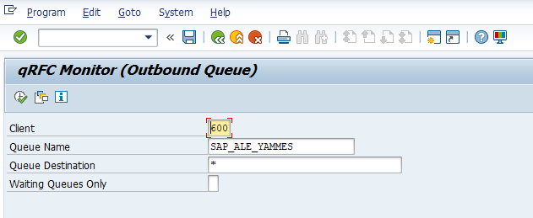 | 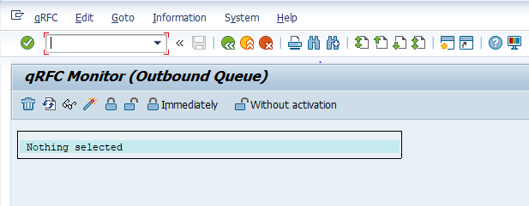

Step2: enter the transaction /nsm58 and give the TRFC Function name as RBP_AAE and check No of Entries < 200.
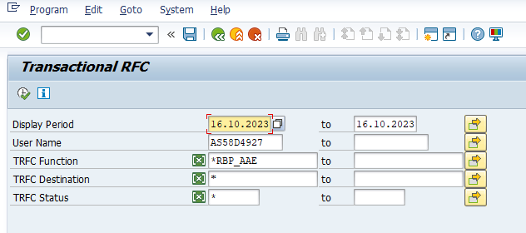 | 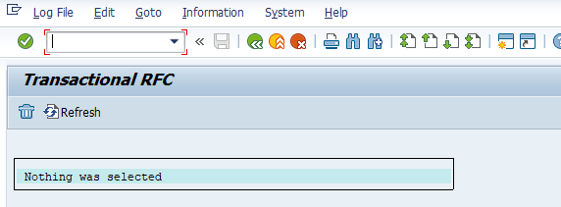

Step3: Enter the transaction /nsmq2 and give the Queue name as X* and check the number of entries for X* queues. No of Entries < 100
Next enter queue name as CF* and check No of Entries Error/Retry < 1000, SYSFAIL = 0
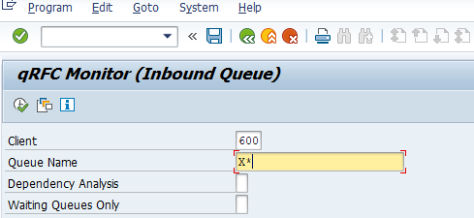 | 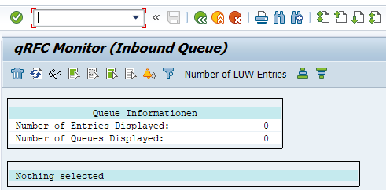

Step4: Enter the transaction /nsmlg to check all the response time which are below 1500ms.
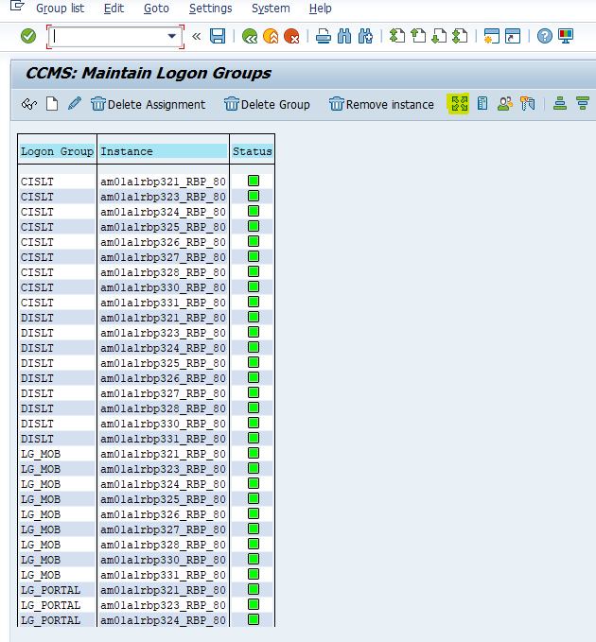 | 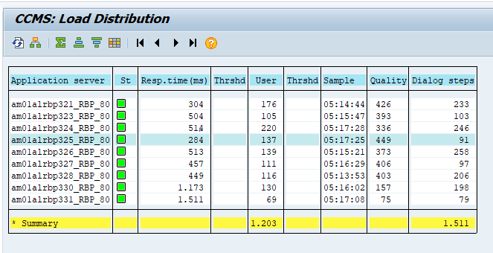

Step5: Enter the transaction /nRZ03 and check all servers are active.
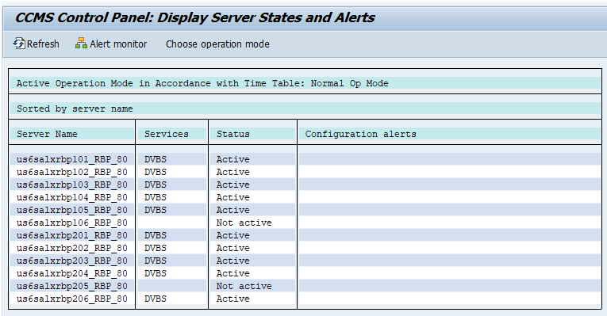 Step6: Enter the transaction sm14 to check the status of system.
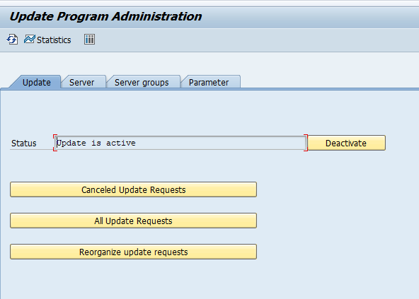
Step7: Enter the transaction ldap to check the status of system.
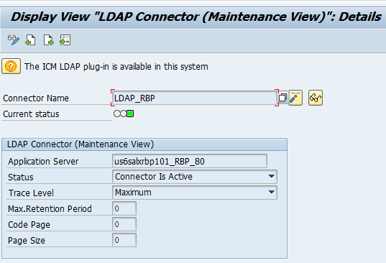
Step8: login to RWP system and enter the transaction st04 to check the Hana replication status of system.
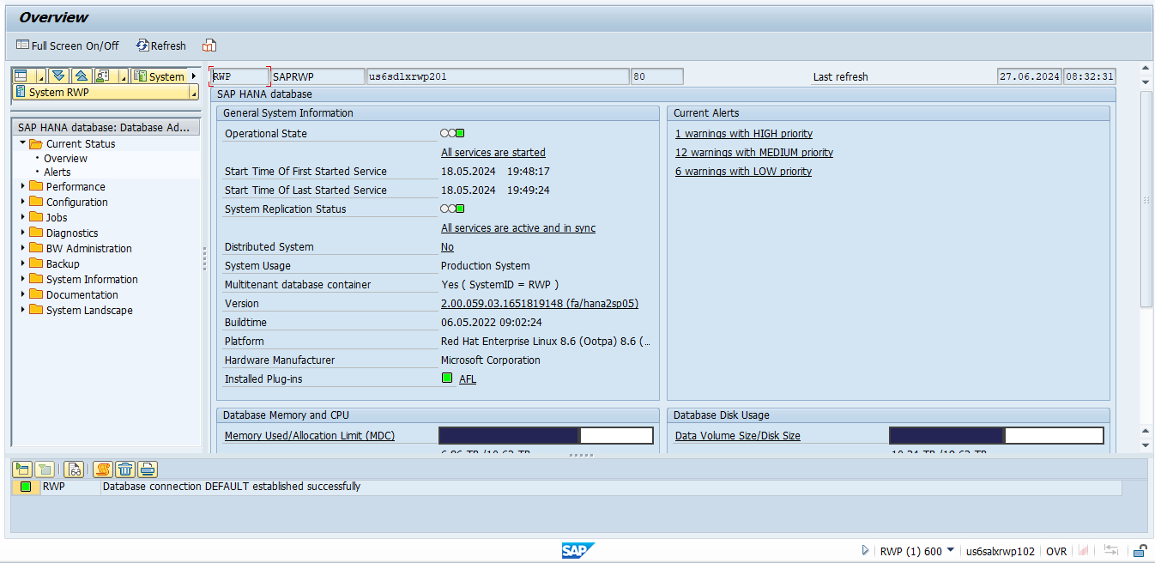
Step9: Repeat the same procedure by logging into RWP system.
Input Format
NA
Output Format
NA
Output Medium
Print
Screen Summary
NA
Business Logic:
For detailed specification of the development please refer to Appendix – Program Logic
Run Mode
Foreground

System Operation Specification
NA

Data
NA

Security
NA

Revision History
Version | Source |  | Reason For Revision
Version | Deployment | BAU | Reason For Revision
1.0 | June-2024. | NA | This is the first issue of the document and initial version created for AutoSAP_001.

Appendices

Appendix – Selection Screen Definitions
NA

Appendix – Testing Objective
- Every day the hourly RBP&RWP monitoring is done by logging into SAP.
- This process involves checking the various transactions such as rz03, sm58, smlg, smq1, smq2, st04, sm14, and ldap.
- At the end of monitoring a report is prepared and an email notification is sent to BASIS team summarizing the hourly monitoring results.

Appendix – Screen Layout Definition
NA

Appendix – Program Logic
Element ID | Logic Description
Autosap_RBP&RWP Hourly Monitoring | Step 1:  - Log in to the RBP system.  - Enter transaction code `/nsmq1` and execute.  - Check the number of entries for Queue `SAP_ALE_YAMMES`. Ensure the count is less than 200.  - Next, enter `CF*` as the queue name and check for the number of entries. Ensure the count is less than 1000.  Step 2:  - Enter transaction code `/nsm58`.  - Provide the TRFC Function name as `RBP_AAE`.  - Check for the number of entries. Ensure the count is less than 200.  Step 3:  - Enter transaction code `/nsmq2`.  - Use `X*` as the queue name and check for the number of entries. Ensure the count is less than 100.  - Next, enter `CF*` as the queue name. Check for the number of entries with Error/Retry count less than 1000 and SYSFAIL equal to 0.  Step 4:  -Enter the transaction /nsmlg to check all the response time which are below 1500ms.  Step 5:  - Enter the transaction /nRZ03 and check all servers are active.  Step 6:  - Enter the transaction sm14 to check the status of system  .Step 7:  - Enter the transaction ldap to check the status of system.  Step 8:  - login to RWP system and enter the transaction st04 to check the Hana replication status of system.  Step 9:  - Repeat the same procedure by logging into RWP system.
Appendix – Output Layout Details
NA
Appendix – Sample Output Formats
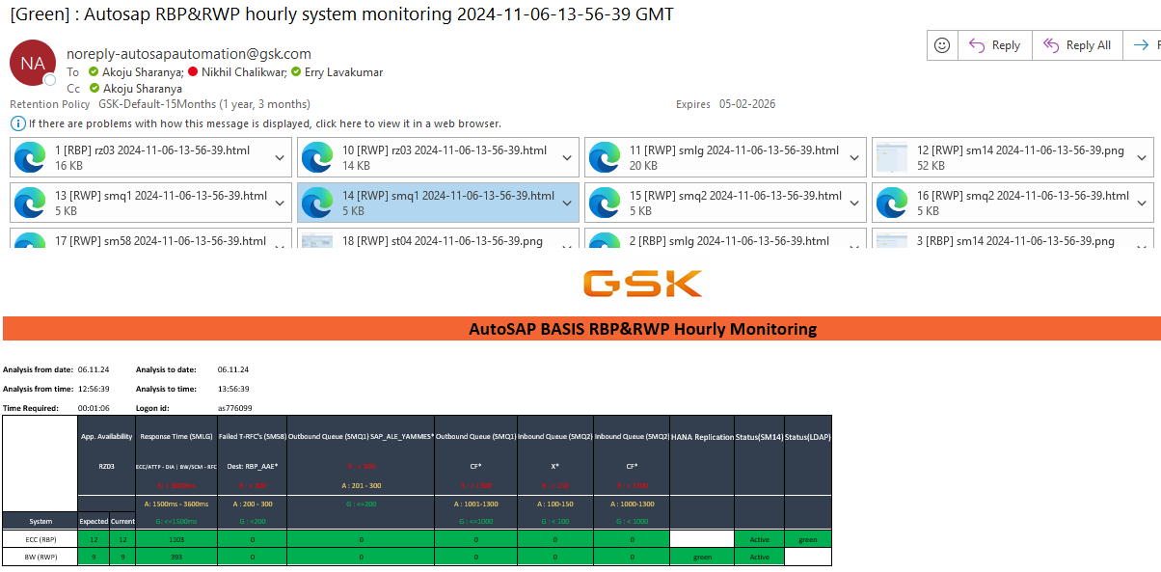

Appendix – Function Module Detail
NA
Appendix – Further Solution-specific sections
NA
Appendix – IDOC Detail
NA
Appendix – Data Dictionary Objects
NA
Appendix – Portal / Java Developments
NA
Appendix – Data
NA

